VaproShield New Product Announcement

WrapShield RS Rain Screen Vapor Permeable Water Resistive Barrier (WRB) and Air Barrier (AB) Membrane with Built-in Rain Screen Drainage Matrix

Contact:
Carol Danhof
616-608-9995
carold@innovative-mr.com

GIG HARBOR, WA – 5/13/2015 VaproShield, the industry leaders of innovative, breathable membranes systems for roofs and walls, announces the new product release WrapShield RS™ Rain Screen with built-in rain screen drainage matrix offering three drainage matrix options: 3mm, 7mm, and 11mm.

WrapShield RS Rain Screen is a vapor permeable, water resistive barrier (WRB) air barrier (AB) membrane featuring:
- Durable rain screen drainage matrix, factory-bonded directly to the vapor permeable WRB/AB membrane
- One-step installation of rain screen cavity and WRB/AB
- Unimpeded vertical drainage plane allowing water and moisture vapor to escape the building envelope, helping to prevent the destructive forces of moisture intrusion
- Three rain screen drainage matrix depths: 3mm, 7mm, and 11mm
- 3mm matrix creates minimal rain screen cavity for use with conventional siding, trim and windows
- 3mm matrix offers cost effective rain screen cavity behind stucco and cultured stone veneers
- 7mm and 11mm matrices offer enhanced drainage performance for building code compliance and/or for more demanding applications
- Factory installed integrated tape which adheres in all weather conditions, including below freezing temperatures, wind and rain
- Horizontal lap guides to ensure proper shingle installation
- Works with all VaproShield flashing accessories, taking the guesswork out of third-party product selection
- Direct replacement for furring strips and battens
- Zero VOC’s eliminates health risks of workers and residents at installation site
- Up to 180 days of exposure before cladding installation
- 20 year material warranty

WrapShield RS Rain Screen WRB/AB membrane provides a secondary defense against bulk water intrusion – under primary building cladding – and allows buildings to rapidly dry out. By allowing buildings to “breathe,” by creating a rain screen cavity, WrapShield RS Rain Screen helps to reduce the effects of moisture damage, mold, mildew and rot that can cause structural damage.

“This membrane allows contractors and installers to create a cost-effective rain screen cavity which can reduce the effects of water damage,” notes Managing Partner Lee Snyder. “Moisture intrusion causes a host of issues in the building envelope, mostly mold and wood rot/decay, which can cause serious health and safety risks to building occupants. We are very excited about our 3mm [WrapShield RS Rain Screen matrix] because it offers traditional siding/stucco installers the ability to create a simple, effective rain screen cavity without having to modify the building envelope application. There are multiple benefits in a single unique product; air barrier for energy savings, high drying capacity [50 perms] to help dry out cementitious siding products and factory installed integrated tape to ease installation.”

Testing is integral to the success of the VaproShield membranes, and their solution-based approach helps contractors reduce liability. VaproShield membranes, flashings and vapor permeable sealants are fully tested in real world conditions as well as in the lab. “Our products are meticulously tested to ensure maximum performance together as a system, making it easy to create an energy saving air barrier system,” notes Snyder. “We even put samples outside in Seattle downpours for real world testing.”

WrapShield RS Rain Screen is Class A Fire Rated and passes all the standard tests for WRB/AB.

All VaproShield membranes conform to the most rigorous green building standards and have been engineered to contribute LEED points for Indoor Environmental Quality and Energy & Atmosphere.

WrapShield RS Rain Screen is suitable for all construction types including: commercial, multi-family, institutional, medical and high-end residential.

VaproShield technical experts will be available for interviews at AIA Expo in Atlanta on May 14-16, booth 1844. Material samples are also available.

Who is VaproShield?
For over a decade, VaproShield has designed and manufactured high performance mechanically attached and self-adhered vapor permeable water resistive barriers (WRB), air barrier (AB) membranes and accessories to create a total solution-based approach to protecting the building envelope. Their innovative features, such as integrated tape on the membranes, permeable hybrid fluid-applied flashing for rough openings, WRB sealant and various other accessories, have been rigorously tested together to maximize life-long building envelope performance and minimize building failure rates.

For information about VaproShield, contact Carol Danhof at 616-608-9995, carold@innovative-mr.com or visit www.VaproShield.com.
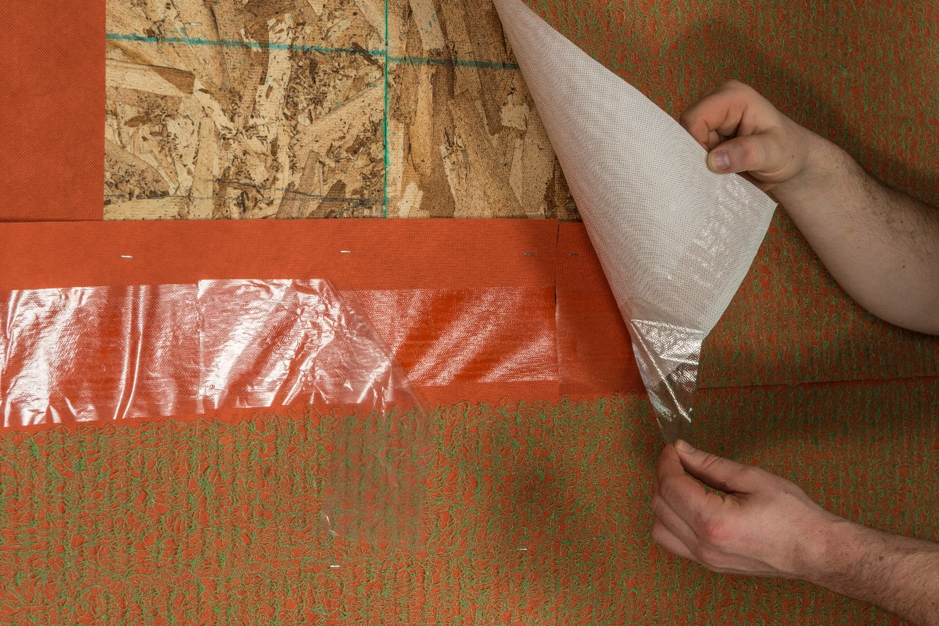
Factory installed integrated tape adheres in all weather conditions, including below freezing temperatures, wind and rain.

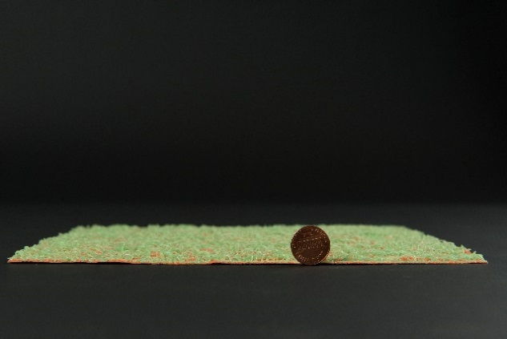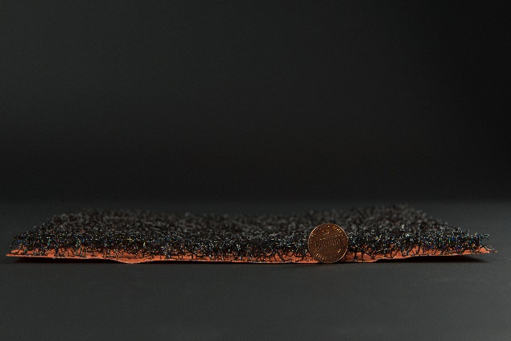
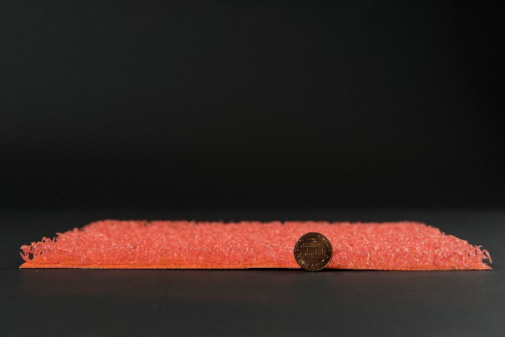
WrapShield RS Rain Screen vapor permeable water resistive barrier (WRB) air barrier (AB) with built-in rain screen drainage matrix, 3mm (green),7mm (black),11mm (orange).

###

Contact:
Carol Danhof
616-608-9995
carold@innovative-mr.com

BACKGROUNDER
Stucco Buildings and the Damaging Effects of Moisture –
Why a Simple Drainage Plane Can Avoid Costly Renovations

Stucco buildings can face extremely costly and damaging structural problems due to the fact that, without a proper drainage plane, water is trapped, and the building’s walls become a breeding ground for mold.¹⁰
Synthetic Stucco (EIFS) was a “lawsuit magnet” in the 90’s. Water could not escape, and caused severe rotting. It has been brought back successfully, but with a drainage plane incorporated into the design.⁴
All stucco is susceptible to water trapping issues. In Minnesota, homeowners have had repair bills upwards of $175,000, and even $700,000. Some homes have been rebuilt more than once.⁶ The problem is nationwide. In Florida, buildings were tested over time by Roger G. Morse AIA, and Paul E. Haas CSP, CIH. They concluded that stucco in Florida is failure-prone, and that water control capabilities are greatly improved with drainage plane implementation.¹⁰
In Pennsylvania, stucco problems are rampant. A family trying to sell their home ended up having it torn down to the studs, and needing upwards of $120,000 in repairs after a stucco test was conducted by a prospective buyer. Not visible from the outside, once the stucco was removed, it was made apparent that the entire house was rotting.³
Also in Pennsylvania, a family had to spend $200,000 to keep their million dollar home. The rot caused by trapped water from stucco was so bad that a home inspector was able to crush a 2x6 stud with his bare hands. The same home inspector stated that in the Philadelphia area, stucco house rot is a billion dollar problem.⁵
A high end contractor in Philadelphia believes the solution to homes new and old that are experiencing water damage behind stucco is the incorporation of a rain screen system.⁴
A monastery in WI is currently seeking to raise money to cover $50,000 repairs for stucco and mold removal.⁷
A Civic Center in British Columbia, Canada is also currently facing a massive repair bill caused by stucco and mold created by stucco-trapped water. Their cost is estimated at $4 million. The building is only 20 years old.⁹
A City Hall Annex in Destin, FL is requiring a $70,000 repair after water damage was found in the building. Further assessment showed that “exterior stucco walls had been absorbing water for years resulting in wood rot and water damage. ¹”
Construction and architecture websites, Contractors, Architects, and Home Inspectors all recommend the implementation of a rain screen design for prevention of catastrophic water damage in buildings with stucco cladding.

1. Algarin, Matt. "A Four-phased Plan: Water-logged City Hall Annex to See Repairs." News. February 24, 2015. Accessed May 12, 2015.
2. Dickinson, Elizabeth. "Revisiting EIFS, the Once-Maligned Cladding System That May Help Architects Meet New Energy Codes." Architect. August 5, 2013. Accessed May 12, 2015.
3. Donovan, Jim. "3 On Your Side: Hidden Damage In Stucco Homes." CBS Philly. July 17, 2013. Accessed May 12, 2015.
4. "Education & Events." Newer Stucco Luxury Homes Experiencing Structural Damage. October 15, 2009. Accessed May 12, 2015.
5. Han, Nydia. "Construction Problem Leaves Local Homes Rotting." 6abc Philadelphia. November 8, 2013. Accessed May 12, 2015.
6. Holladay, Martin. "To Install Stucco Right, Include an Air Gap." GreenBuildingAdvisor.com. November 12, 2010. Accessed May 12, 2015.
7. Kloepping, Sarah. "Monks Hope to Raise Funds to save St. Nazianz Monastery." HTR Media. April 8, 2015. Accessed May 12, 2015.
8. Lstiburek, Joseph. "Building Science Insights." BSI-029: Stucco Woes-The Perfect Storm — Building Science Information. December 12, 2009. Accessed May 12, 2015.
9. Payne, Sarah. "Repair Bill for Port Moody Could Hit Nearly $4 Million - The Tri-City News." The Tri-City News. April 23, 2015. Accessed May 12, 2015.
10. Roger G. Morse, AIA and Paul E. Haas CSP, CIH. n.d. "Best2 - Case Studies." nibs.org. Accessed May 12, 2015. http://c.ymcdn.com/sites/www.nibs.org/resource/resmgr/BEST/BEST2_010_WB4-1.pdf.

###

