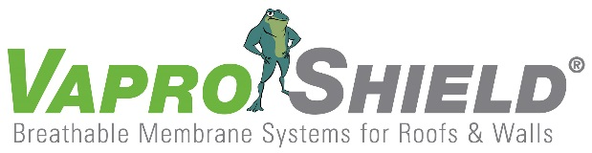

VaproShield Products Showcase Sustainability:
Proven Green by Industry-Leaders in Eco-Friendly Design and Construction
Contact:
Carol Danhof
616-608-9995
carold@innovative-mr.com

GIG HARBOR, WA – 10/20/2014 VaproShield has been committed to the development and continued improvement of sustainable building materials since the company’s formation. Recently, VaproShield’s versatile product line was shown to conform to the most rigorous green building standards including: Living Building Challenge, Net Zero Energy House, Passivhaus, COTE/AIA Top Ten Green Projects and LEED Platinum. Designed to be durable and environmentally friendly, VaproShield products contain zero VOC’s, zero Red List chemicals (as determined by the Living Building Challenge) and do not require flammable and/or toxic primers for application.

“We believe in investing in sustainability,” explains Phil Johnson, Managing Partner at VaproShield. “Since the very beginning, we’ve built innovative products that reduce exposure to dangerous chemicals – and we pride ourselves on that – but we’re constantly striving to do better. We continually educate our staff [on sustainability] to ensure our products are on the cutting-edge of green design.”

VaproShield performs regular, voluntary internal audits to guarantee their products are free of harmful chemicals. All VaproShield products are safe to transport, handle and install in all weather conditions. The installation process is proven safe for contractors and does not require the use of safety equipment such as protective eyewear, respiratory masks or gloves. Product features like self-adhering capabilities and zero primer requirements allow for faster, more efficient installation to reduce labor costs and material waste.

“Our goal is to make sustainable design easy for people,” says Johnson. “So, to achieve that goal, we created an excellent product – something people would want to use – and brought green design into it. Anyone who uses VaproShield products on their construction projects is bringing in eco-friendly design, even if sustainability wasn’t the builder’s end goal. It’s that simple.”

VaproShield’s sustainable elements extend well beyond initial installation. The products’ air barrier technology reduces energy consumption and provides superior indoor air quality, thus passing on the benefits of environmental design to the building’s occupants for the life of the building. VaproShield’s solution-based products protect the building envelope to maximize its performance; this can reduce contractor liability and increase building longevity. VaproShield products are 100% recyclable for end of life building demolitions.

VaproShield technical experts will be available for interviews at GREENBUILD in New Orleans, October 22nd through 24th. Material samples are available at Booth 639.

Who is VaproShield?
For over a decade, VaproShield has designed and manufactured high performance mechanically attached and self-adhered vapor permeable water resistive barriers (WRB), air barrier (AB) membranes and accessories to create a total solution-based approach to protecting the building envelope. Their innovative features, such as integrated tape on the membranes, permeable hybrid fluid-applied flashing for rough openings, WRB sealant and various other accessories used in a variety of applications, have been rigorously tested together to maximize life-long building envelope performance and minimize building failure rates.

For information about VaproShield, contact Carol Danhof at 616-608-9995, carold@innovative-mr.com or visit www.VaproShield.com.

###

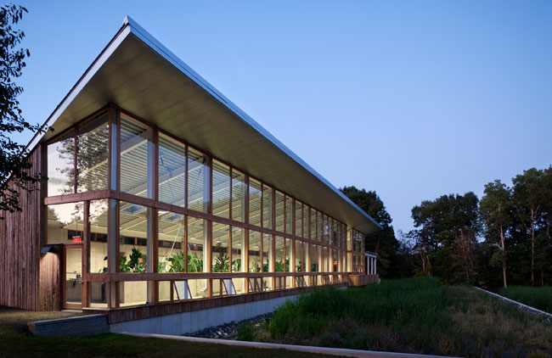
Omega Institute for Holistic Studies trusted VaproShield’s membranes to meet the Living Building Challenge’s rigorous standards. Photo courtesy of Green Source. | National Renewable Energy Lab, solely dedicated to advancing renewable energy and energy efficiency technology, achieved LEED Platinum status using VaproShield products.

 | 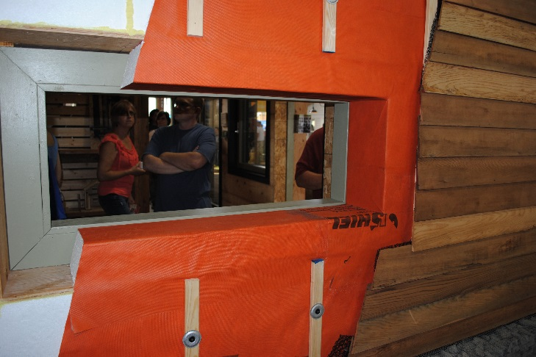
VaproShield products helped Yannell House achieve Net Zero Energy status by creating an airtight envelope, maximizing energy efficiency and reducing costs. | North Dakota State U Passivhaus uses very little energy for heating and cooling costs with its airtight building envelope using VaproShield WrapShield SA® Self-Adhered.

