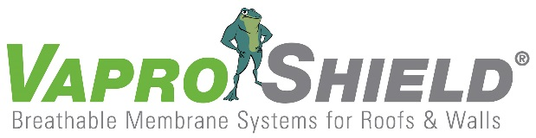

VaproShield New Product Announcement

RevealShield SA® Self-Adhered
For Open Joint Rain Screen Cladding Systems

Contact:
Carol Danhof
616-608-9995
carold@innovative-mr.com

GIG HARBOR, WA – 10/14/2014 VaproShield, the industry leaders of innovative, breathable membranes systems for roofs and walls, announces the new product release of RevealShield SA® Self-Adhered for Open Joint Rain Screen Cladding Systems.

RevealShield SA® Self-Adhered for Open Joint Rain Screen Cladding Systems, black UV stable, vapor permeable, water resistive barrier (WRB) sheet membrane features:
- Zero VOC’s
- High Vapor Permeance
- Exceptional UV Stability
- Low Temperature Application
- No Primer Required
- No Mechanical Fasteners
- No Tapes

RevealShield SA® Self-Adhered provides a secondary defense against bulk water intrusion – after primary building cladding – and allows buildings to rapidly dry out. By allowing buildings to “breathe,” RevealShield SA® Self-Adhered helps to reduce the effects of moisture damage, mold, mildew and rot that can cause structural damage. It is suitable for all construction types including: commercial, multi-family, institutional, medical and high-end residential.

RevealShield SA® Self-Adhered is proven tear, rip and puncture resistant during and after construction. The product can be applied in temperatures of 20°F (-6°C) and rising. Designed to be entirely self-adhering, RevealShield SA® Self-Adhered does not require any primers. This eliminates the health risks of workers and installation site exposure to harmful and volatile VOC’s and chemicals. The product can be installed in either direction: vertical or horizontal giving construction teams the option for faster installation.

VaproShield offers a total solution-based approach to flashing rough openings, windows and building penetrations to ensure zero water and air leakage and still offer vapor permeability. In addition to the 59”W RevealShield SA Self-Adhered roll, VaproShield offers RevealFlashing, 11 3/4”W precut flashing rolls designed to reduce installation time and increase field application accuracy. “By having precut rolls, crews don’t need to cut (the large roll) on the worksite. This saves so much time in the field,” notes Lee Snyder, VaproShield Managing Partner. “I have seen a single worker flash a commercial window in as little as 15 – 30 minutes (2-4 windows/hour) with extreme accuracy, because so few pieces are needed,” says Snyder. “Other products take about one hour to complete a window. We are so pleased to offer contractors these labor savings features and products.”

Testing is integral to the success of the VaproShield solution-based approach, helping to reduce contractor liability. Their membranes, flashings and vapor permeable sealants are fully tested in real world conditions as well as the lab. “Our products are meticulously tested to ensure maximum performance together as a system, making it easy to create an energy saving air barrier system,” notes Snyder. “We even put samples outside in Seattle downpours for real world testing.”

“We are pleased to say RevealShield SA® Self-Adhered is Class A Fire Rated,” notes Snyder. RevealShield SA® Self-Adhered earned the top tier fire resistance rating as well as a Flamespread Index of zero and a Smoke Development Index of 75.

VaproShield’s versatile product lines conform to the most rigorous green building standards and have been engineered to contribute LEED points for Indoor Environmental Quality and Energy & Atmosphere.

“We know about the dangerous effects of VOC’s and off gassing and we are committed to ensure our products are free of these harmful components,” says Phil Johnson, VaproShield Managing Partner. “VaproShield is dedicated to remaining on the cutting-edge of green design and providing earth-friendly, innovative product solutions to create a better building envelope. We believe RevealShield SA® Self-Adhered is representative of this mission.”

VaproShield technical experts will be available for interviews at GREENBUILD in New Orleans, October 22nd through 24th. Material samples are available at Booth 639.

Who is VaproShield?
For over a decade, VaproShield has designed and manufactured high performance mechanically attached and self-adhered vapor permeable water resistive barriers (WRB), air barrier (AB) membranes and accessories to create a total solution-based approach to protecting the building envelope. Their innovative features, such as integrated tape on the membranes, permeable hybrid fluid-applied flashing for rough openings, WRB sealant and various other accessories used in a variety of applications, have been rigorously tested together to maximize life-long building envelope performance and minimize building failure rates.
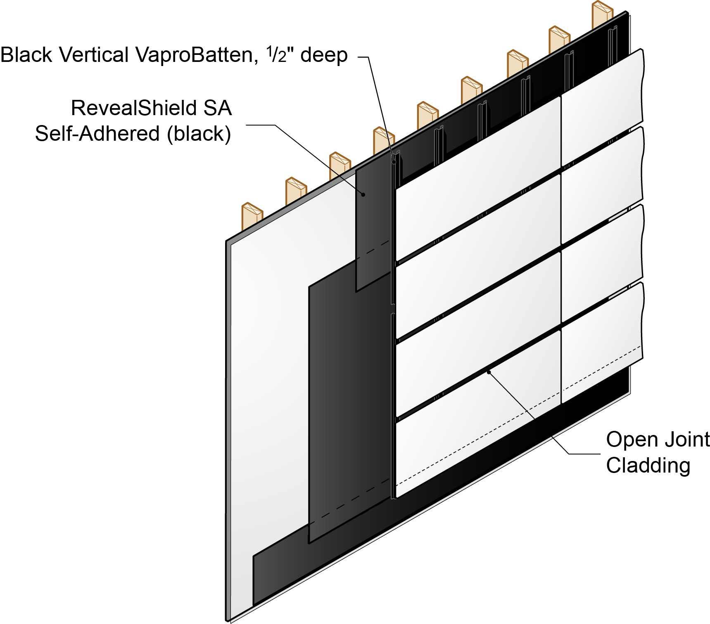

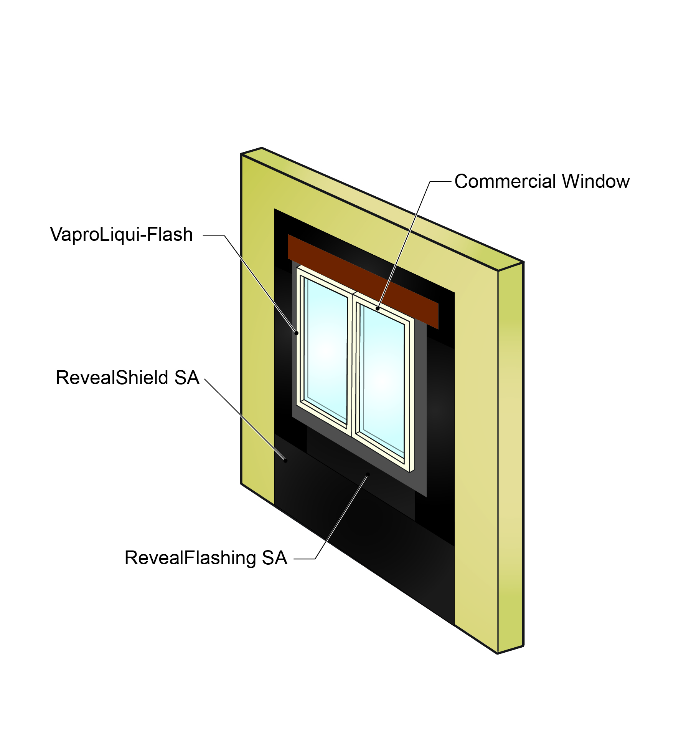
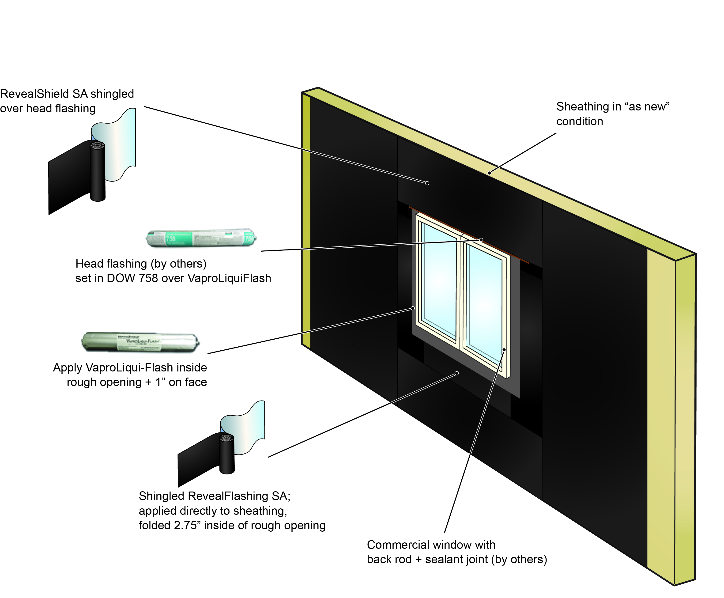

For information about VaproShield, contact Carol Danhof at 616-608-9995, carold@innovative-mr.com or visit www.VaproShield.com.

###

