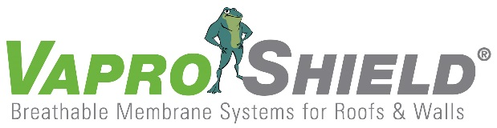

VaproShield Membrane Protecting Cincinnati Multi-Million Dollar Development

Contact: Carol Danhof
616-608-9995
carold@innovative-mr.com

GIG HARBOR, WA – 11/13/2015 – VaproShield is proud to be part of the revitalization of Cincinnati’s central riverfront with Phase II construction on the multi-million dollar, mixed-use development, The Banks. Due for completion late this year, Phase II of this multi-stage development faced challenges regarding the application of the Weather Resistive Barrier (WRB)/Air Barrier (AB) that risked causing construction delays. The construction team originally considered a fluid-applied membrane for the 9-story residential-retail building; however, they were confronted with the many limitations of fluid-applied WRB/AB.

Combs Interiors’ Senior Estimator, Josh Turner, describes the moment he realized a fluid-applied membrane could not meet the project’s many demands. “The temperatures at which we were going to begin installing the air [barrier] membrane on the project [were] too cold for a fluid-applied [product]…the building was going up in sections. To have a crew come in and do the fluid-applied would have been…up to 10-15 mobilizations on the project.”

Aware of Phase II’s very aggressive building schedule and unique needs, Turner and his team made the switch to VaproShield’s WrapShield SA® Self-Adhered water resistive, vapor permeable air barrier sheet membrane. WrapShield SA Self-Adhered can be installed in below freezing temperatures and with regular construction equipment. Unlike fluid-applied membranes, phase construction friendly WrapShield SA Self-Adhered is entirely self-adhering and does not require the use of primers. This feature was crucial as some parts of The Bank’s Phase II construction were already completed upon the installation of the WRB/AB. A messy primer-based installation risked spraying onto the completed areas of the development.

“Because [Phase II is] in downtown, there’s quite a bit of wind,” explained Turner. “The other thing we were worried about with the fluid-applied was ….getting the over-spray on the windows that are below.”

New to self-adhered sheet applied membranes, Turner’s team quickly learned to work with WrapShield SA Self-Adhered. Built for easy installation, WrapShield SA Self-Adhered was installed in sections as construction of the building continued. This approach allowed Phase II of The Banks project to remain on time for completion without increasing the demand for labor.

“The [VaproShield] team was great,” said Turner. “The technical assistance they gave us was really great. There was a lot more support for us than…from many other fluid-applied [companies]…it was a good product to use.”

VaproShims™ Rain Screen Accessory
Over 150,000 of VaproShield’s VaproShim Neoprene/EPDM accessories were used under the horizontal cladding attachment components on the Banks development, creating the desired vertical rain screen drainage plane for cladding, while sealing fastener penetrations. This simple design was a minimal cost while adding substantial drying capacity to the building envelope.
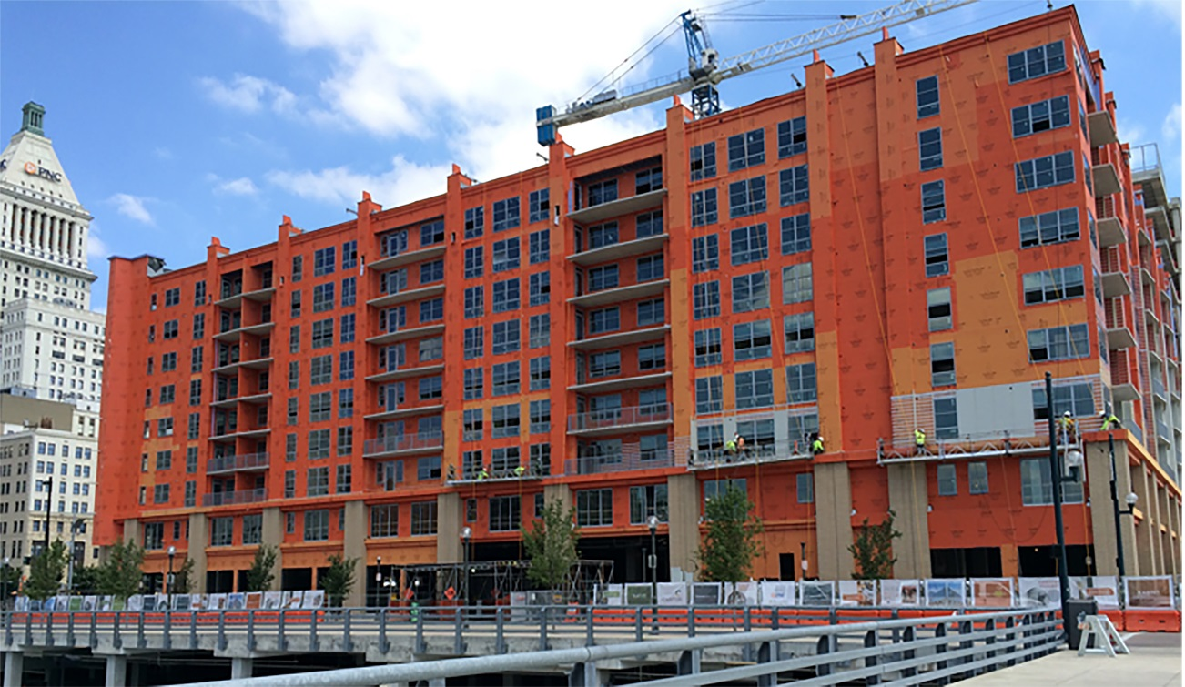

150,000 sq. ft. of WrapShield SA Self-Adhered Water Resistive Vapor Permeable Air Barrier sheet membrane was installed on The Banks Phase II Mixed-Use Building after initially choosing a fluid-applied product.

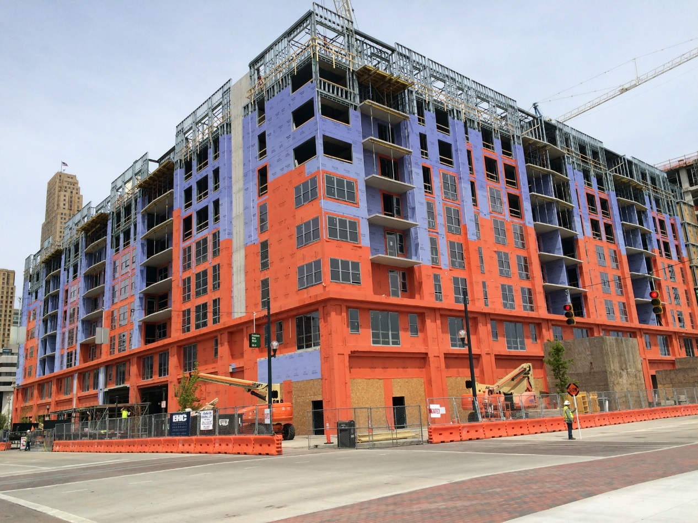

WrapShield SA Self-Adhered is applicable for all climates and weather conditions, and can be installed in temperatures as low as 20°F (-6° C) which made VaproShield a better choice than the fluid-applied product that would have been impractical and expensive to be applied in the windy, cold conditions of this project.

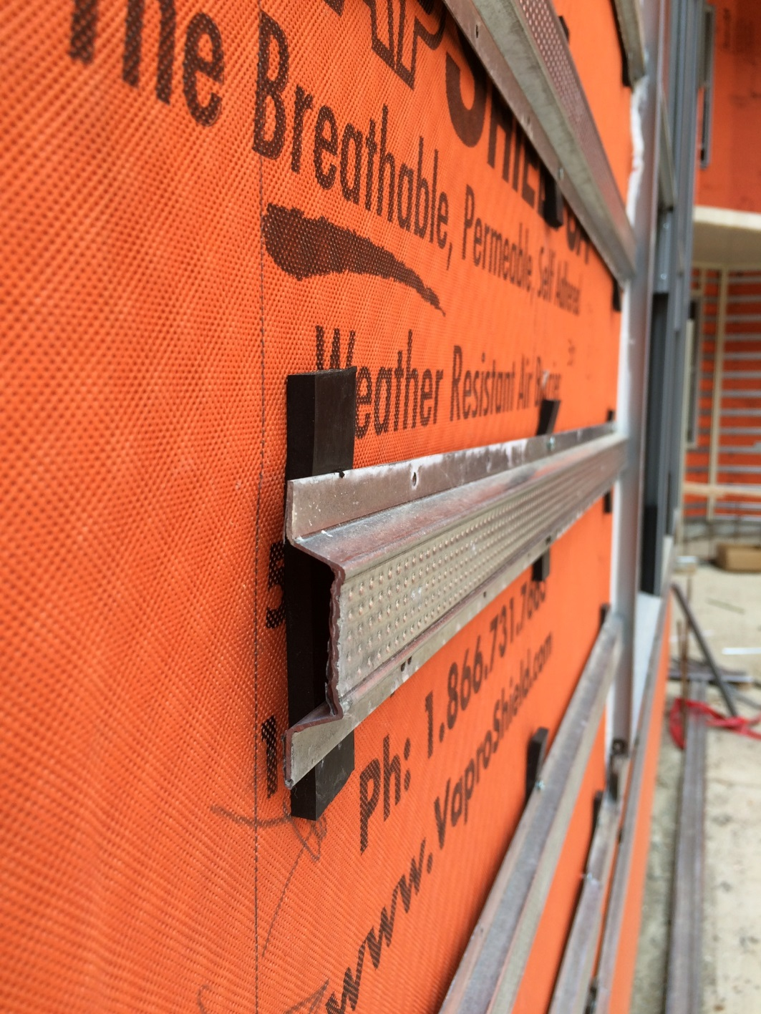

VaproShims used under horizontal cladding attachment created a small, effective ¼” rain screen cavity, allowing for unimpeded vertical drainage of moisture away from the building envelope.

VaproShield technical experts will be available for interviews at GREENBUILD in Washington D.C., November 18th through the 22nd. Material samples are available at Booth #2341.

Who is VaproShield? For over a decade, VaproShield has designed and manufactured high performance mechanically attached and fully self-adhered vapor permeable water resistive barriers (WRB), air barrier (AB) membranes and accessories to create a total solution-based approach to protecting the building envelope. Their innovative features, such as UV stable membranes for open joint cladding applications, integrated tape on the membranes, permeable hybrid fluid-applied flashing for rough openings, WRB sealant and various accessories used in a variety of applications, have been rigorously tested together to maximize life-long building envelope performance and minimize building failure rates.

For information about VaproShield, contact Carol Danhof at 616-608-9995, carold@innovative-mr.com or visit www.VaproShield.com.
###

