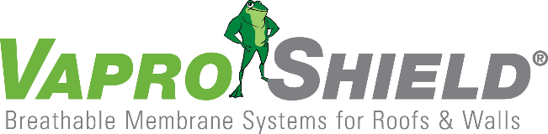

VaproShield’s Two Component System™ Honored by The National Institute of Building Sciences’ with Award of Merit for a High-Performance Innovation

Contact: Carol Danhof
616-608-9995
carold@innovative-mr.com

GIG HARBOR, WA – 01/19/2017 – VaproShield’s Two Component Air Barrier System™ has received the 2016 Beyond Green™ Award of Merit for a High-Performance Innovation by the Sustainable Buildings Industry Council (SBIC). This unique award recognizes the innovations that shape, inform, and catalyze the high-performance building market, as well as the real-world application of high-performance design and construction practices.
“We are honored to be recognized by an industry pillar like The National Institute of Building Sciences,” says Phil Johnson, VaproShield Managing Partner. “our Two Component Air Barrier System is an exceptional innovation that provides real benefits to architects, builders, installers, and the residents for years to come.”

A program of the prestigious National Institute of Building Sciences, the Beyond Green Awards recognize those projects and activities that best exemplify the eight design objectives of a high-performance building: sustainability, accessibility, aesthetics, cost-effectiveness, functionality, productivity, historical sensitivity, safety and security. The first of its kind to earn the award, VaproShield’s Two Component Air Barrier System goes beyond exemplifying the eight design objectives; it meets the rigorous criteria outlined in the Whole Building Design Guide®, benefits both the industry as well as the end user, and addresses a specific issue in the market.

“Prior to the development of VaproShield’s Two Component Air Barrier System, there had been a brief crisis in the construction industry,” said Phil Johnson, Managing Partner. “As codes began requiring the installation of continuous air barrier systems, contractors failed to account for additional labor required to install a continuous air barrier, resulting in overages and improper installations —people were demanding a solution, and we felt up to the challenge.”

Effectively used on all types of buildings, in all weather, with little field training, VaproShield created a solution that benefits the owner/client and the industry as a whole. Their innovation brings energy savings for the life of the building, saves contractors up to 50% on installation, eliminates VOC exposure, and ensures a building envelope is breathable (50+ perm rating)-thus promoting improved indoor air quality and drastically reducing the incidence of mold, mildew, and rot within the building envelope.

VaproShield received their award on January 12th at a special Beyond Green Awards Luncheon, held during The National Institute of Building Sciences Fifth Annual Conference and Expo: Building Innovation 2017, the week of January 9-12, in Washington, D.C. The Two Component Air Barrier System will be published as a case study on the Whole Building Design Guide® website and be announced in The National Institute of Building Sciences newsletter.

Who is VaproShield?
For over a decade, VaproShield has designed and manufactured high performance mechanically attached and fully self-adhered vapor permeable water resistive barriers (WRB), air barrier (AB) membranes and accessories to create a total solution-based approach to protecting the building envelope. Their innovative features, such as UV stable membranes for open joint cladding applications, integrated tape on the membranes, permeable hybrid fluid-applied flashing for rough openings, WRB sealant and various accessories used in a variety of applications, have been rigorously tested together to maximize life-long building envelope performance and minimize building failure rates.
About the National Institute of Building Sciences
The National Institute of Building Sciences, authorized by public law 93-383 in 1974, is a nonprofit, nongovernmental organization that brings together representatives of government, the professions, industry, labor and consumer interests to identify and resolve building process and facility performance problems. The Institute serves as an authoritative source of advice for both the private and public sectors with respect to the use of building science and technology.
See more information about the 2017 Beyond Green Awards here.

For information about VaproShield, contact Carol Danhof at 616-608-9995, carold@innovative-mr.com or visit www.VaproShield.com.
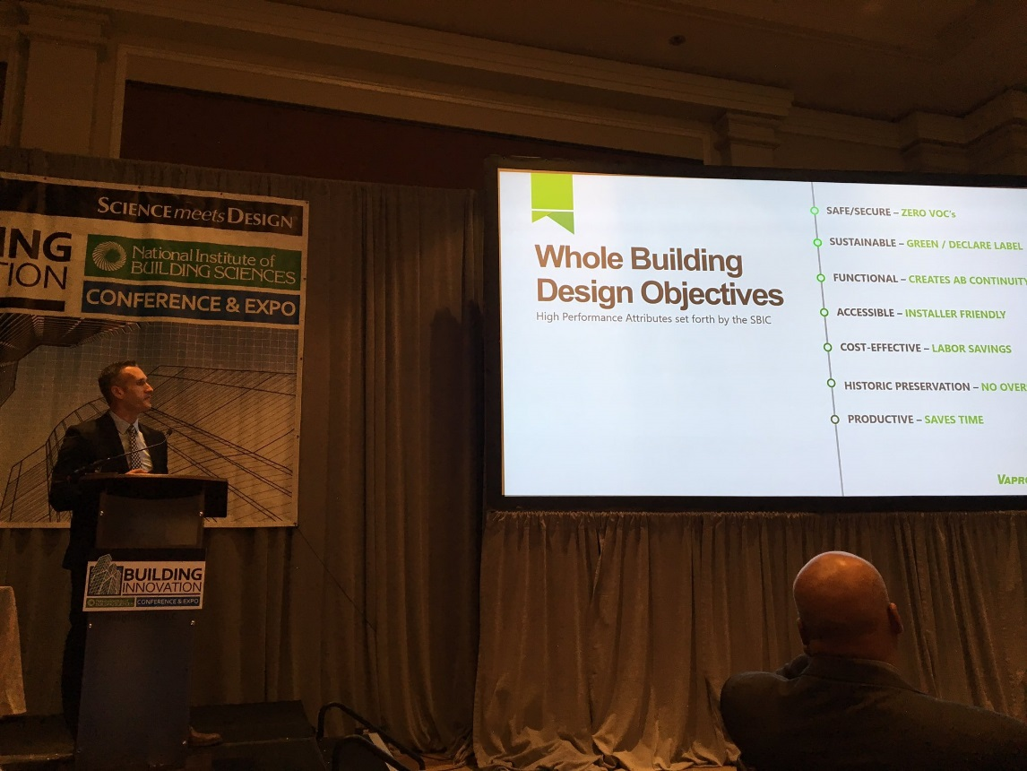
VaproShield’s Dan Clancy presents the Two Component System at the Beyond Green™ Awards Luncheon in front of leaders in the building community.
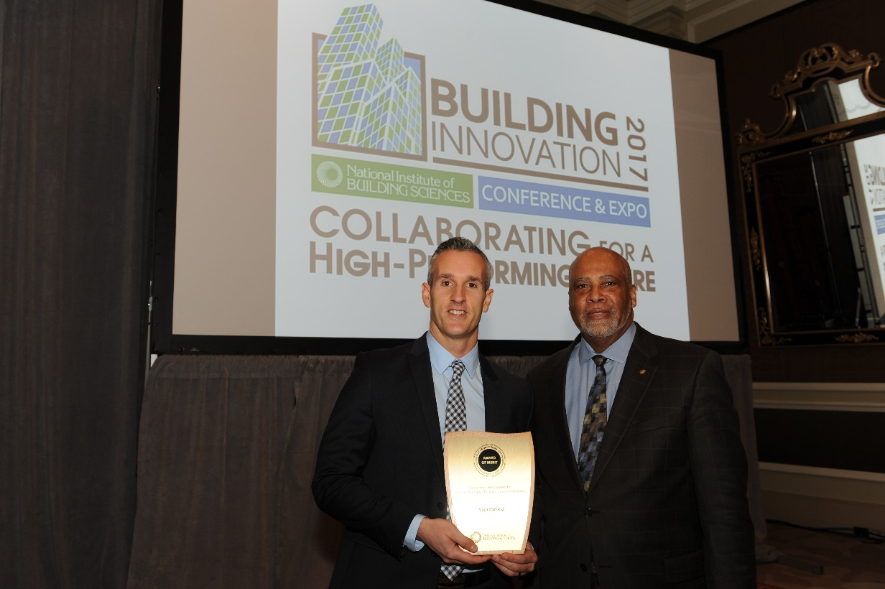
Dan Clancy, left, accepts the Award of Merit in Innovations for High-Performance Buildings and Communities from National Institute of Building Sciences President Henry L. Green.
###

