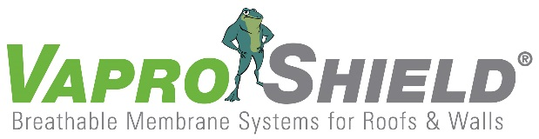

VaproShield Membrane Remains Intact After Hurricane

Contact: Carol Danhof
616-608-9995
carold@innovative-mr.com

GIG HARBOR, WA – 11/03/2017 – Following a site visit to assess the damage of Hurricane Irma on the J.W Marriot Marco Island Resort—a VaproShield project in Marco Island, Florida— it was noted that 65,000 square feet of meticulously installed RevealShield SA Self-Adhered withstood the forces of the hurricane during its historic September 10th landfall. To the relief of installation crews, less than 10% of the membrane was damaged.

"When I first saw the areas with membrane still intact, it felt like a huge accomplishment for our team,” noted Aaron Gould, VaproShield Technical Manager of East Coast/Latin America. “Irma [winds] were exceptionally strong, and I believe our extensive testing paid off for the crew of the JW Marriott."

The tenacious “self-adhered” adhesive formula was critical in reducing wind tear damage. In addition, the UV-stable black RevealShield SA Self-Adhered will prove instrumental in drying out the building’s cementitious substrate throughout months of rehabilitation following the hurricane.

“At VaproShield we are committed to providing the maximum amount of membrane durability in our industry,” said Phil Johnson, Managing Partner. “We strive to continuously push the limits of what our WRB/ Air-barrier sheet membranes can endure. The fact that they [membrane(s)] survive extreme storm conditions is a huge testament to that.”

This is the second instance of a VaproShield membrane enduring hurricane conditions, with WrapShield SA Self-Adhered gaining industry recognition in 2012 for remaining intact on Long Beach High School during Hurricane Sandy. Twelve months later in October 2013, the addition was still without cladding and protected only by WrapShield SA Self-Adhered. Despite this long-term exposure, the structure was cleared for occupancy showed no signs of leaks within the building envelope when opened to the public.

The J.W Marriott in Marco Island has resumed construction and is projected to open later than anticipated in Fall of 2018.

Who is VaproShield? For over a decade, VaproShield has designed and manufactured high performance mechanically attached and fully self-adhered vapor permeable water resistive barriers (WRB), air barrier (AB) membranes and accessories to create a total solution-based approach to protecting the building envelope. Their innovative features, such as UV stable membranes for open joint cladding applications, integrated tape on the membranes, permeable hybrid fluid-applied flashing for rough openings, WRB sealant and various accessories used in a variety of applications, have been rigorously tested together to maximize life-long building envelope performance and minimize building failure rates.

For information about VaproShield, contact Carol Danhof at 616-608-9995, carold@innovative-mr.com or visit www.VaproShield.com.
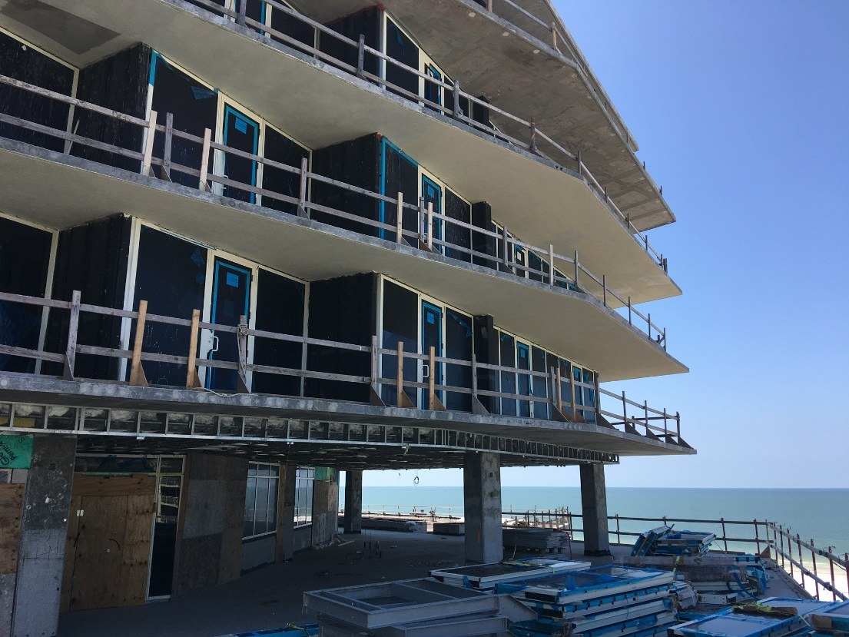
65,000 square feet of RevealShield SA Self-Adhered (black) withstood the forces of Hurricane Irma

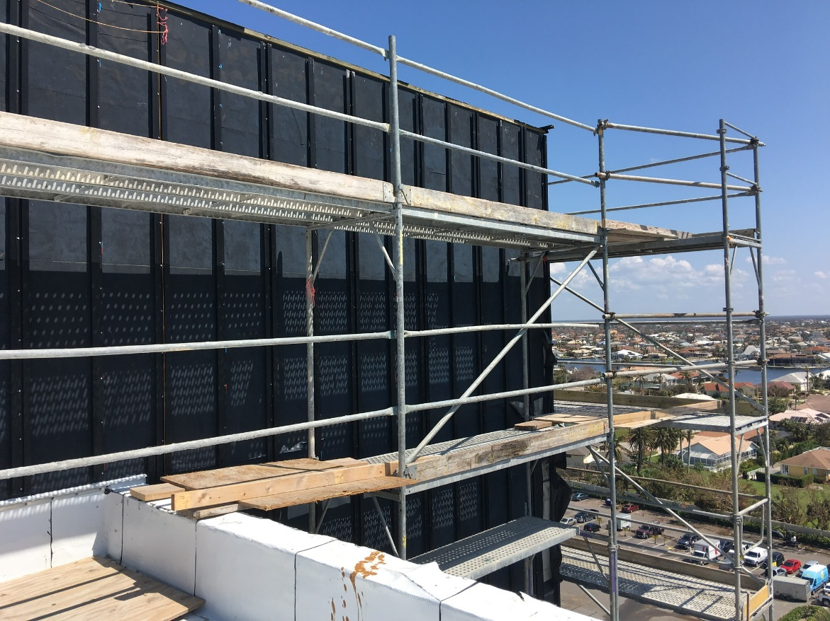
To the relief of installation crews, less than 10% of the membrane was damaged.

###

