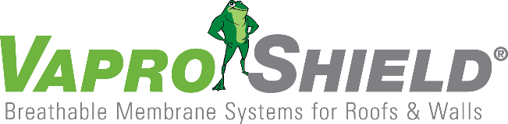

VaproShield Honored by Durability + Design Magazine with Elevation Award for Air Barrier and Moisture Management

Contact: Carol Danhof
616-608-9995
carold@innovative-mr.com

GIG HARBOR, WA – 09/27/2017 – Radius at the Banks, a VaproShield project in Cincinnati, Ohio, has received the 2017 Elevation Award for ‘Air Barrier and Moisture Management’ by Design + Durability magazine. This unique award recognizes exceptional air barrier and moisture management systems—including related accessories—that excel in design and installation detailing.
“It is a constant privilege to work with talented professionals who want to build a sustainable future,” says Phil Johnson, VaproShield Managing Partner. “We are proud of our contribution to Radius at the Banks; recognition from an industry pillar such as Design & Durability truly underscores what we accomplished there.”

D+D launched the Elevation Award program to honor architects, contractors, manufacturers, and industry professionals for the outstating work they contribute to the trade. On March 1st D+D invited all readers to nominate projects that effectively demonstrate technical expertise and artisan flair. Through these nominations, formally-unknown companies had the opportunity to highlight the talent of various project teams—from design to application—as well as the quality and performance of the products used.

“Too often, key infrastructure professionals get knee-deep in a project, then move on to the next one and don’t have time to recognize what a great project it was,” said Steven Reinstadtler, 2017 Elevation Award panel judge, in a statement to D+D news. “The Elevation Awards provide a means to get those projects recognized and appreciated by the architectural community.”

In an unprecedented shift towards high-performance design, developers of Radius at Banks decided to switch from a traditional fluid-applied air barrier to VaproShield’s WrapShield SA Self-Adhered WRB/Air Barrier System, in effort to address many financial, ecological, and quality-related concerns. Over 150,000 sq. ft. was installed on the massive development on the banks of the Ohio River, thereby accelerating of the construction phase, and ensuring the longevity of the building envelope. In addition, the VaproShield solution offered significant environmental contributions; it contained none of the toxic VOC emissions or Red List chemicals found in many common building envelope materials.
The awards were presented during a breakfast reception on September 14th at the Lippitt House Museum during CONSTRUCT 2017, in Providence, Rhode Island. Award winners will also be recognized in D+D In Depth and the Fall 2017 issue of Durability + Design magazine.

Who is VaproShield?
For over a decade, VaproShield has designed and manufactured high performance mechanically attached and fully self-adhered vapor permeable water resistive barriers (WRB), air barrier (AB) membranes and accessories to create a total solution-based approach to protecting the building envelope. Their innovative features, such as UV stable membranes for open joint cladding applications, integrated tape on the membranes, permeable hybrid fluid-applied flashing for rough openings, WRB sealant and various accessories used in a variety of applications, have been rigorously tested together to maximize life-long building envelope performance and minimize building failure rates.
About Durability + Design Magazine
Durability + Design is a media network serving the building and design industry. D+D covers material on multiple platforms, with emphasis on building performance and aesthetics, as well as the technology, specification and application of architectural coatings and related materials. Durability + Design offers: educational e-books, problem-solving forums, quizzes, webinars, classified listings, and opportunities to interact online with colleagues. DurabilityandDesign.com, D+D In and D+D News are part of the Technology Publishing Network of paint and coatings editorial products. Related websites and publications include JPCL (the Journal of Protective Coatings & Linings); PaintSquare News; PaintSquare.com and Paint BidTracker.com.

For information about VaproShield, contact Carol Danhof at 616-608-9995, carold@innovative-mr.com or visit www.VaproShield.com.

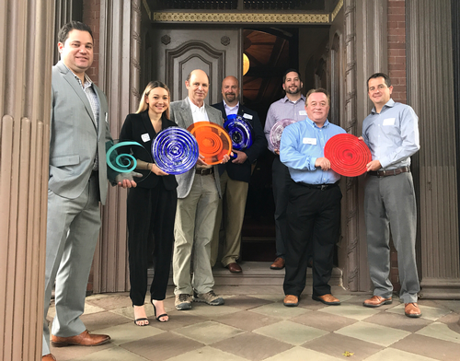
Durability + Design
The awards were presented during a breakfast reception on September 14th at the Lippitt House Museum during CONSTRUCT 2017, in Providence, Rhode Island. Those who accepted awards the ceremony are pictured, from left, Pat Penza, on behalf of VaproShield; Heather Marter, Axalta; Brian O’Farrell, on behalf of ECL Engineered Coatings; Mark Thomas, Tnemec; Josh Poole, Tremco; and Jim Gildea and Bill Bellicoe, Sika Corporation.

###

