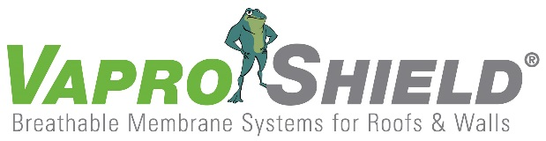

Contractor-Friendly VaproAirBarrier System Reduces Installation Time,
Requires Two Components

Contact:
Carol Danhof
616-608-9995
carold@innovative-mr.com

GIG HARBOR, WA – 11/12/2015 - Built with contractors and installers in mind, VaproShield’s Two Component VaproAirBarrier System allows for complete air barrier continuity with only two components. This fast and efficient air barrier system uses only easy-to-install WrapShield SA Self-Adhered membrane and VaproLiqui-Flash to create a vapor permeable, water resistant seal within the building envelope. The VaproAirBarrier System costs an average of 30-50% less than leading competitors by eliminating the need for additional materials such as joint/corner treatments, tapes, adhesives, and spray equipment. This translates to greater savings on the job-site.

“Being contractor-friendly is our motive,” explains Phil Johnson, VaproShield managing partner. “VaproShield products are specifically built to work together making training and installation easy. Our 99% return/reuse rate [by installers and contractors] says it all.”

The VaproAirBarrier System does more than reduce costs, it helps to ensure crew safety on the job-site. All of the components in the VaproAirBarrier System are free of VOC’s, toxins and red list chemicals making materials safe for handling and repeated exposure. The self-adhering air barrier sheet membrane does not require primers thereby eliminating the need for respirators or special overalls. Scraps and release paper are easily recycled or tossed in on-site refuse containers for fast clean-up.

“We don’t want to slow anyone down,” says Johnson. “We’ve worked to create a product that works whenever they [contractors and installers] work. We want to help keep them on budget and on deadline.”

The most phase construction friendly air barrier system on the market today, the
VaproAirBarrier System offers best in class drying capacity. The VaproAirBarrier System can be installed using basic hand tools in below freezing temperatures. With virtually no weather installation restrictions, the VaproAirBarrier System allows contractors to finish construction on deadline and on budget.
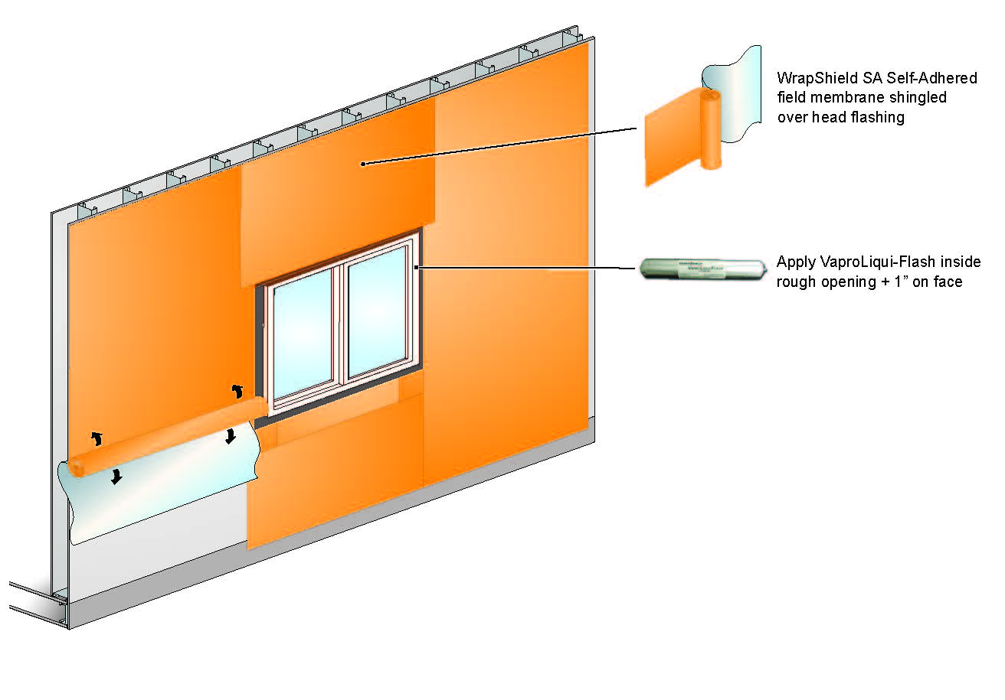
VaproShield’s Two Component air barrier system is contractor friendly,
competitive and sustainable.

VaproShield technical experts will be available for interviews at GREENBUILD in Washington DC, November 18th through 22nd. Material samples are available at Booth #2341.

Who is VaproShield? For over a decade, VaproShield has designed and manufactured high performance mechanically attached and self-adhered vapor permeable water resistive barriers (WRB), air barrier (AB) membranes and accessories to create a total solution-based approach to protecting the building envelope. Their innovative features, such as integrated tape on the membranes, permeable hybrid fluid-applied flashing for rough openings, WRB sealant and various accessories used in a variety of applications, have been rigorously tested together to maximize life-long building envelope performance and minimize building failure rates.

For information about VaproShield, contact Carol Danhof at 616-608-9995, carold@innovative-mr.com or visit www.VaproShield.com.

###

