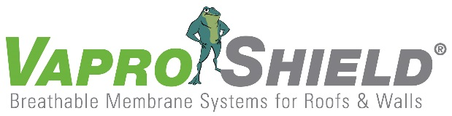

VaproShield Membrane Participates In Experimental,
Post-Disaster Modular Unit
Contact:
Carol Danhof
616-608-9995
carold@innovative-mr.com

GIG HARBOR, WA – 10/14/2014 VaproShield was honored to have WrapShield SA® Self-Adhered Water Resistive Vapor Permeable Air Barrier Sheet selected for use on an experimental, post-disaster housing prototype located in Brooklyn, NY. In development since 2008, the prototype was commissioned by New York’s Office of Emergency Management (OEM) with funding from FEMA. The U.S. Army Corps of Engineers (USACE) was designated as project manager for the prototype’s construction. Designed by Garrison Architects, the “townhouse” style post-disaster housing consists of five modular units – fabricated by Mark Line Industries – which are stacked on top of each other.

“This is an exciting innovation,” comments Phil Johnson, VaproShield Managing Partner. “These [post-disaster housing] units have the potential to provide safe, reliable housing to the victims of natural disaster as they work to rebuild their communities. VaproShield is a proud contributor.”

While the post-disaster prototype will be on-site in Brooklyn for a year, the modular units are designed to be mobile. The modular units were constructed for easy installation, deconstruction and transport.

“The idea is that no matter where a disaster occurs, these modular units can be placed on a truck and taken there,” says Johnson. “The units need to perform well in every climate, as there is no telling where they may end up, and WrapShield SA® Self-Adhered helps with that.”

WrapShield SA® Self-Adhered Water Resistive Vapor Permeable Air Barrier Sheet helps to regulate air flow to keep units cool in the summer and warm in the winter, thus reducing energy costs. WrapShield SA® Self-Adhered was selected for use on this initial prototype as it provides superior weather protection as well as the durability to withstand exposure in a wide variety of climates.

VaproShield technical experts will be available for interviews at GREENBUILD in New Orleans, October 22nd through 24th. Material samples are available at Booth 639.

Who is VaproShield?
For over a decade, VaproShield has designed and manufactured high performance mechanically attached and self-adhered vapor permeable water resistive barriers (WRB), air barrier (AB) membranes and accessories to create a total solution-based approach to protecting the building envelope. Their innovative features, such as integrated tape on the membranes, permeable hybrid fluid-applied flashing for rough openings, WRB sealant and various other accessories used in a variety of applications, have been rigorously tested together to maximize life-long building envelope performance and minimize building failure rates.

For information about VaproShield, contact Carol Danhof at 616-608-9995, carold@innovative-mr.com or visit www.VaproShield.com.

###

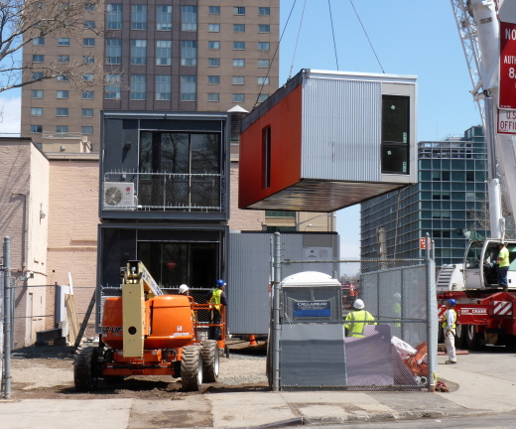 | 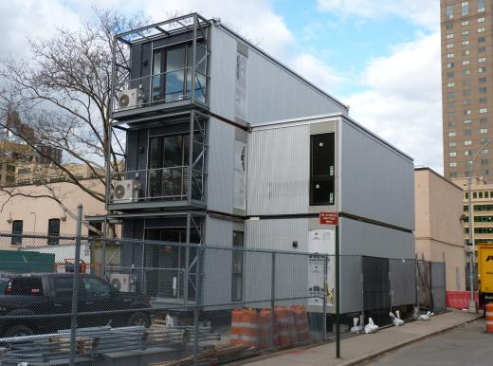
WrapShield SA® Self-Adhered Water Resistive Vapor Permeable Air Barrier Sheet (orange) provides superior protection on NYC’s Post Disaster Housing Prototype.  Photo courtesy of Mary Frost. | In development since 2008, the prototype was designed to provide a safe and comfortable living space for victims of natural disaster.  Photo courtesy of Mary Frost.

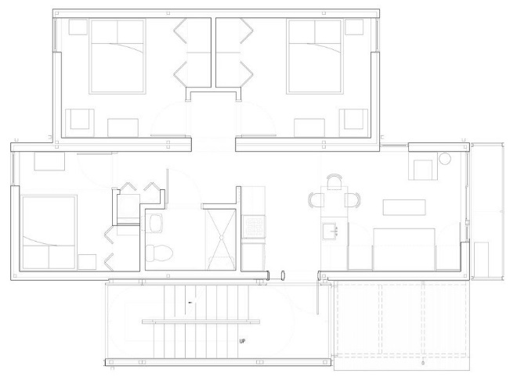
An architectural rendering of a 3 bedroom post-disaster modular home.
Rendering courtesy of Garrison Architects.

