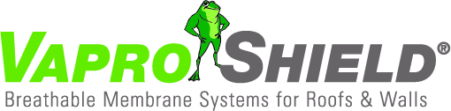
VaproShield Innovative Membranes Approved by Air Barrier Association of America

Contact:
Carol Danhof
616-608-9995
carold@innovative-mr.com

GIG HARBOR, WA - 4/28/2015 VaproShield’s innovative self-adhered vapor permeable, water resistive air barrier membranes: WrapShield SA Self-Adhered and RevealShield SA Self-Adhered (for open joint rain screen cladding systems) received approval from Air Barrier Association of America (ABAA) on April 20, 2015.
Both approved membranes are fully self-adhered water resistive barriers (WRB) and air barriers (AB) with a cutting edge adhesive that does not require primers, is void of VOC’s and can be applied in below freezing temperatures. Since a category for such innovation did not exist, it had to be created. Over the past several months, the VaproShield technical team has worked with the ABAA to implement a new category for high performance, self-adhered, air barrier systems. “The association [ABAA] did not have a category for our innovative membranes,” notes Lee Snyder, Managing Partner. “We are so pleased they worked with us to create the ‘Adhesive Backed Commercial Building Wrap’ category.”
Product information, samples, and technical assistance can be requested on the VaproShield website at vaproshield.com, or by calling 866-731-7663.
VaproShield technical experts will be available for interviews at the AIA Expo in Atlanta, May 14-16, 2015. Material samples are available at Booth 1844.
Below are the certificates of approval.
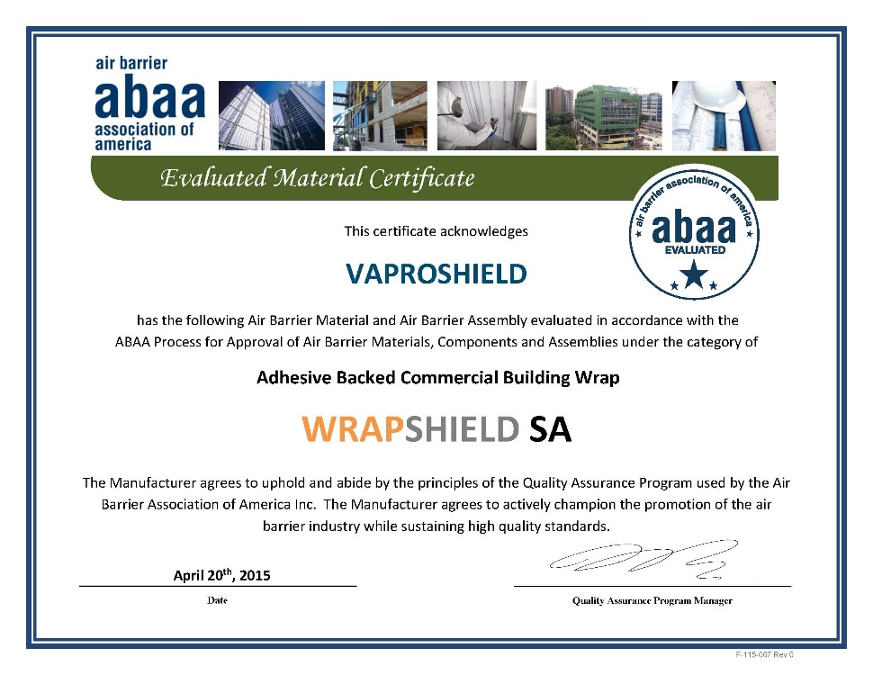
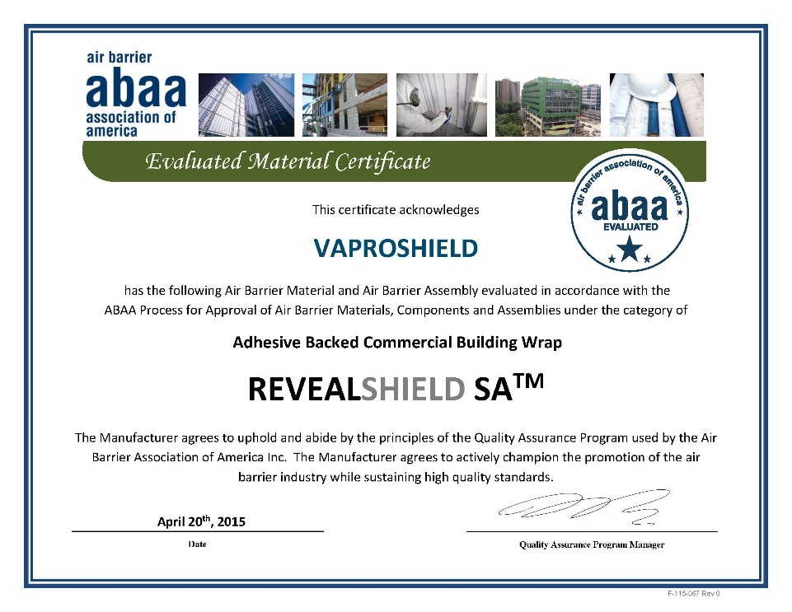
Who is VaproShield?
For over a decade, VaproShield has designed and manufactured high performance mechanically attached and self-adhered vapor permeable, water resistive barrier (WRB), air barrier (AB) sheet membranes and accessories to create a complete solution-based approach to protecting the building envelope. Their innovative features, such as fully self-adhered membranes for both walls and roofs, integrated tape on the membranes at horizontal lap locations, pre-marked horizontal shingle lap line, black WRB/AB membranes for open joint cladding applications, and permeable hybrid fluid-applied flashing for windows, doors and rough openings, have been rigorously tested together to maximize life-long building envelope performance and minimize building failure rates.

For information about VaproShield, contact Carol Danhof at 616-608-9995, carold@innovative-mr.com or visit www.VaproShield.com.

###

