RevealShield SA™ Self-Adhered Honored by Top Industry Expert as the Year's Most Innovative and Useful Building Membrane
Contact:
Carol Danhof
616-608-9995
carold@innovative-mr.com

GIG HARBOR, WA – 10/24/2014 VaproShield's RevealShield SA Self-Adhered for Open Joint Cladding Systems was recognized as a prestigious “Record Product”- one of the year's most innovative and useful building products – by industry leader, Architectural Record magazine. Drawing over 500 entries in multiple categories, submissions for Record Product were scrutinized by judges from leading architecture and design firms who specialize in the given products and their specifications. All submissions were rated by the judging panel based upon different critical criteria such as innovation and usefulness. RevealShield SA Self-Adhered was one of only 14 winners in the Facades category.

“We are humbled to be recognized by an industry expert like Architectural Record,” says Phil Johnson, VaproShield Managing Partner. “RevealShield SA Self-Adhered is an exceptional product that provides real benefits to architects, builders and installers. We're excited for this opportunity to show [RevealShield SA Self-Adhered’s] many advantages and to share it with a wider audience.”

A black, UV stable, water resistive vapor permeable air barrier membrane, RevealShield SA Self-Adhered works as a part of an open joint, rain screen cladding system. Designed with healthy buildings in mind, RevealShield SA Self-Adhered offers exceptional UV stability, produces zero VOC's and is 100% recyclable. It holds a Class A fire rating and has a Flamespread Index of zero.

RevealShield SA Self-Adhered installs in temperatures as low as 20º F and requires no primer allowing for maximized efficiency and ease of installation. RevealShield SA Self-Adhered is tear, rip and puncture resistant and can be installed in either direction: vertical or horizontal. This gives construction teams the option for faster installation. Highly vapor permeable, RevealShield SA Self-Adhered helps to reduce incidents of mold, mildew and rot to protect the building envelope and reduce energy consumption when installed as part of an air barrier system.

“The VaproShield team put countless hours of testing and research into RevealShield SA Self-Adhered,” says Lee Snyder, Managing Partner at VaproShield. “We wanted to create a unique, high performance, UV sustainable product that was easy to install in all climates. RevealShield SA Self-Adhered is the culmination of this work and we're very proud to have it recognized for these attributes.”

RevealShield SA Self-Adhered will be honored with a major editorial feature detailing the product's outstanding performance and design in Architectural Record's December 2014 issue.

Who is VaproShield?
For over a decade, VaproShield has designed and manufactured high performance mechanically attached and self-adhered vapor permeable water resistive barriers (WRB), air barrier (AB) membranes and accessories to create a total solution-based approach to protecting the building envelope. Their innovative features, such as self-adhering adhesive, integrated tape on the membranes, and permeable hybrid fluid-applied flashing for rough openings, have been rigorously tested together to maximize life-long building envelope performance and minimize building failure rates.

For information about VaproShield, contact Carol Danhof at 616-608-9995, carold@innovative-mr.com or visit www.VaproShield.com.

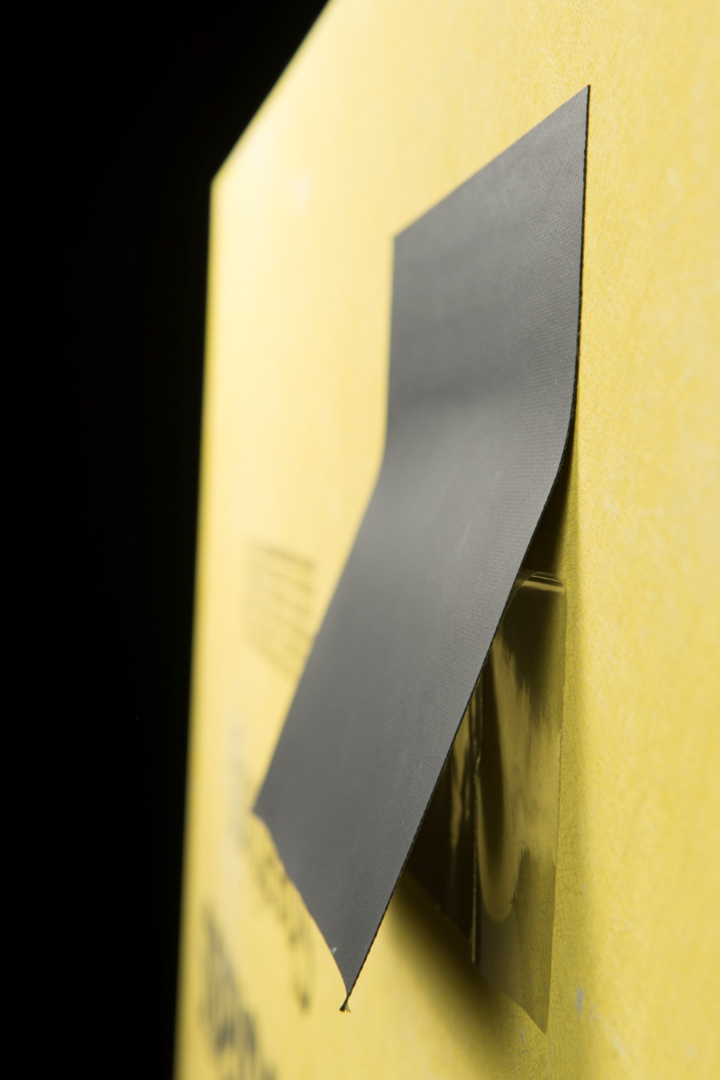
RevealShield SA Self-Adhered advanced technology adhesive requires no primers and will adhere to virtually all substrates.
###

Crash Course on VOC’s
Contact:
Carol Danhof
616-608-9995
carold@innovative-mr.com

VaproShield membranes contain zero VOC’s, posing no health risks, or exposure to hazardous chemicals during transportation, storage, installation, post-installation and removal.

DEFINITION

Volatile organic compounds (VOCs) refers to organic chemical compounds which have significant vapor pressures and which can affect the environment and human health. VOCs are numerous, varied, and ubiquitous. Although VOCs include both man-made and naturally occurring chemical compounds, it is the anthropogenic VOCs that are regulated, especially for indoors where concentrations can be highest. VOCs are typically not acutely toxic but have chronic effects. Because the concentrations are usually low and the symptoms slow to develop, analysis of VOCs and their effects is a demanding area.

INDOOR AIR QUALITY AND VOC’S
Since people today spend most of their time at home or in an office, long-term exposure to VOCs in the indoor environment can contribute to sick building syndrome. In offices, VOC results from new furnishings, wall coverings, and office equipment such as photocopy machines, which can off-gas VOCs into the air. Good ventilation and air conditioning systems are helpful at reducing VOC emissions in the indoor environment. Studies also show that relative leukemia and lymphoma can increase through prolonged exposure of VOCs in the indoor environment.

There are two standardized methods for measuring VOCs, one by the National Institute for Occupational Safety and Health (NIOSH) and another by Occupational Safety and Health Administration (OSHA). Each method uses a single component solvent; butanol and hexane cannot be sampled, though, on the same sample matrix using the NIOSH or OSHA method.

The United States Environmental Protection Agency (EPA) has found concentrations of VOCs in indoor air commonly to be 2 to 5 times greater than in outdoor air and sometimes far greater. During certain activities indoor levels of VOCs may reach 1,000 times that of the outside air. Studies have shown that individual VOC emissions by themselves are not that high in an indoor environment, but the indoor total VOC (TVOC) concentrations can be up to five times higher than the VOC outdoor levels. New buildings especially, contribute to the highest level of VOC off-gassing in an indoor environment because of the abundant new materials generating VOC particles at the same time in such a short time period. In addition to new buildings, we also use many consumer products that emit VOC compounds, therefore the total concentration of VOC levels is much greater within the indoor environment.

VOC concentration in an indoor environment during winter is three to four times higher than the VOC concentrations during the summer. High indoor VOC levels are attributed to the low rates of air exchange between the indoor and outdoor environment as a result of tight-shut windows and the increasing use of humidifiers.

HEALTH RISKS
Respiratory, allergic, or immune effects in infants or children are associated with man-made VOCs and other indoor or outdoor air pollutants.

Some VOCs, such as styrene and limonene, can react with nitrogen oxides or with ozone to produce new oxidation products and secondary aerosols, which can cause sensory irritation symptoms. Unspecified VOCs are important in the creation of smog.

Health effects include:

Eye, nose, and throat irritation; headaches, loss of coordination, nausea; damage to liver, kidney, and central nervous system. Some organics can cause cancer in animals; some are suspected or known to cause cancer in humans. Key signs or symptoms associated with exposure to VOCs include conjunctival irritation, nose and throat discomfort, headache, allergic skin reaction, dyspnea, declines in serum cholinesterase levels, nausea, emesis, epistaxis, fatigue, dizziness.

For information about VaproShield, please contact Carol Danhof at (616) 608-9995. Carold@innovative-mr.com, or visit www.VaproShield.com.

###

